Core64 LED Array

Manufacturing Instructions

|  |  |  |  |
| --- | --- | --- | --- |
| Doc. Ver. | Description | Date | Author |
| A | First draft developed. | 2023-05-22 | Andrew Geppert |
|  |  |  |  |
|  |  |  |  |

# INTRODUCTION

Details regarding the manufacturing and assembly process for the LED Array. Initial draft developed for the V1.3 LED Array.

# PCB

Standard materials:

Material: FR4

Board Thickness: 1/16” inch

Copper Weight: 1 oz.

Solder Mask: White

Silkscreen: Black

Finish: HASL

Leadfree: No

Rails and panelization: manufacture’s choice

# COMPONENTS

**Serially Addressable RGB LED World Semi P/N WS2813C**

1. The most prominent and challenging part of this assembly process is ensuring high quality LEDs are used to avoid rework after assembly and testing is completed. See Appendix A and B in this document to identify GOOD and BAD LED types which have been observed.
2. Observe moisture and component supplier baking recommendations for the LEDs in this assembly.
3. As of this writing, the only component allowed is WS2813C. A possible substitution may be WS2913B (much brighter with increased current draw) but must be approved by the author of this document.

**Capacitors**

1. Substitutions are allowed. Please inform the author of this document prior to procurement to confirm the substitution details.

# ASSEMBLY

LED orientation:

Pin 1 in upper left with DOT on silkscreen and NOTCH on LED.

# APPENDIX A: GOOD LEDS

This LED package resulted in LED Arrays with 100% yield.

Initially purchased as LCSC P/N ________ in 2022.

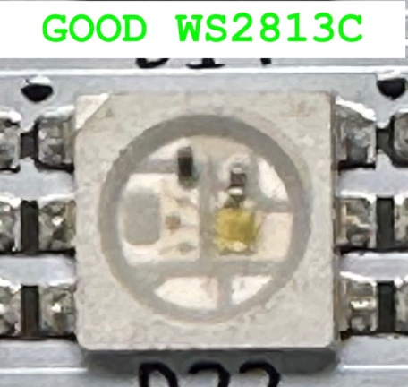

This LED sampled May 2023 and test assembled by the author, 64 of 64 worked first time.

DIGIKEY P/N 1597-1594

<https://www.digikey.com/en/products/detail/seeed-technology-co-ltd/601000200/8120706>

Supplied from SEEED Technology Co., Ltd

Utilizing Worldsemi WS2813B (5050) Ver. No. 5

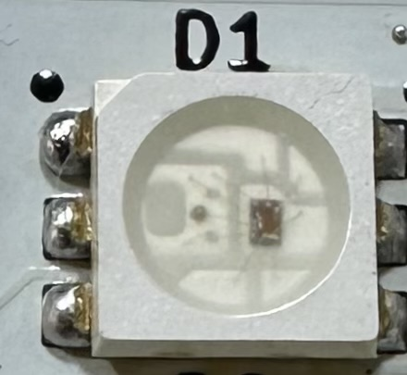

# APPENDIX B: BAD LEDS

This version of the WS2813C provided low yields.

Initially purchased as LCSC P/N ________ in 2023.

# APPENDIX C: LED REFERENCE NOTES

A test method for LED epoxy potting quality:

<https://youtu.be/SWh7Watb_LE>

from

<https://wp.josh.com/2016/10/29/a-quick-test-for-crappy-ws2812b-neopixels/>

Alternative to WS2812 is SK6812

<https://cpldcpu.wordpress.com/2016/03/09/the-sk6812-another-intelligent-rgb-led/>

More stories:

<https://talk.vanhack.ca/t/psa-ws2812b-leds-may-not-be-what-you-think-they-are/5626>